|  |
| --- |
| **North Campus** |
| **Midterm Exam (Hourly-I) Summer - 2021** |



**Subject: World History SubmissionDay/Date: Saturday 7th Aug, 2021**

**Time Allowed: 08.30 – 11:30 Instructor: Ms. RubiaShoukat**

**Submission Duration: 2 Hours Program: BBA**

**Max. Marks: 10**

**Department of Business Administration**

**Please follow the instructions carefully:**

1. Write your answers in a Word file and upload the file before the due time on BlackBoard.
2. Write your name and registration ID on the first page of your Word file.
3. **Answer scripts can be uploaded onBlackBoardwithin or before its deadline. Therefore, do not wait for the last hour to avoid any unforeseen problems.**
4. **Submission of answer copy(ies) will be considered acceptable through BlackBoard only. Therefore, do not submit your document through email or any other medium.**
5. Use 12 pt. font size and Times New Roman font style along with 1-inch page margins.
6. Follow the requirements of the word limit and the marking criteria while writing your answers.
7. Provide relevant, original and conceptual answers, as this exam aims to test your ability to examine, explain, modify or develop concepts discussed in class.
8. Do not copy answers from the internet or other sources. The plagiarism of your answers may be checked through Turnitin.
9. Recheck your answers before the submission on BlackBoard to correct any content or language related errors.
10. Double check your word file before uploading it on BlackBoard to ensure that you have uploaded the correct file with your answers.

Instructions:

* Attempt all question
* Each question carries 5 Marks

Q: 1 Identify the geographical features of China in the map given below. Also explain how the geography remains a key reason for the isolation of Chinese civilization for years?

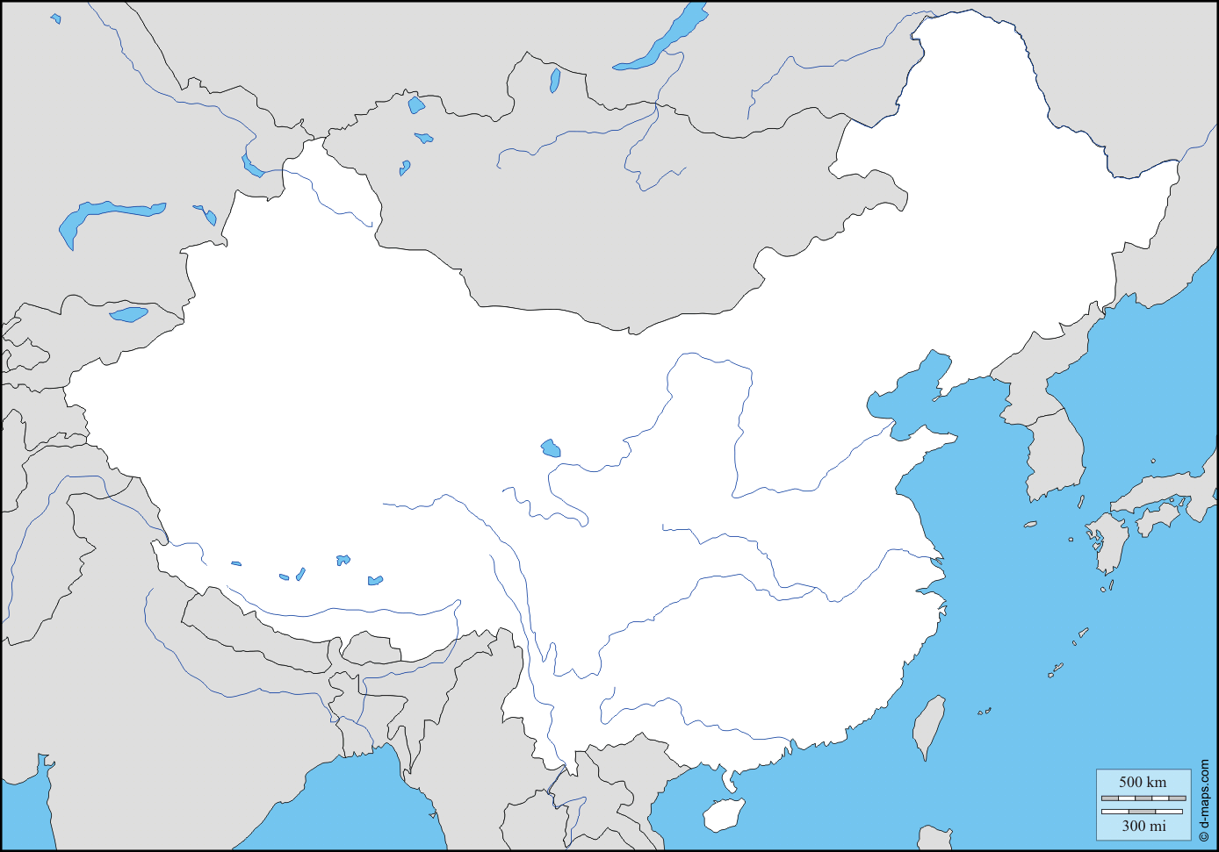

Q: 2 How did the nomadic tribes surrounding The Holy Roman Empire contributed in its decline? Also mention the names of those tribes and how did they formed new states, establishing the basis of Modern European that we see today?

Note: 15 Marks are allocated for the mcqs from Chapter 1-7